Syllabus Geometry

Sprenger Website: SprengerMath.weebly.com
Expectations

A productive and respectful classroom environment is essential for learning. Individual behavior can support or undermine the learning environment. To make our classroom work well, here is what is expected of you:
- Be ready for the beginning of class when the bell rings by having homework ready to be checked and following directions promptly.
- Bring your pencil, notebook, book, and calculator to class every day.
- Listen silently when it is someone else’s turn to talk.
- No cell phones/ipods etc. will be allowed to be used during instructional time or they will be confiscated.
- Stay focused on the current learning activity and put forth your best effort.
- Follow all school rules as explained in the student handbook.
In general, these expectations will be upheld with consequences that begin with verbal warnings, and progress to detentions or school-level discipline for serious or repeated offenses.

Grade Weights
Students must demonstrate a proficiency level of 70% or higher twice on each standard, including the final exam, in order to pass the class.

Standard Exams and Final Exam– 70 %
- Before students can begin a Standard exam, students must fully and accurately complete the standard review as well as show proficiency or higher on all Learning Targets.
- If a student does not demonstrate proficiency or higher on their first attempt at the standard, in order to earn additional opportunities, students are required to complete additional practice/review assignments and intervention. Parents will be contacted if a student scores below 70% and the student does not take steps to work towards proficiency.
- There will be a strict opportunity window for taking/re-taking standards. Once the next standard test begins, the previous will no longer be available.

Assignments & Practice – 20%
- Independent Practice is an essential part of learning. Assignments should be labeled, organized, and clearly show all work. Be prepared to submit your work for checking. Students are encouraged to check odd answers in the back of the book. Assignments must be completed to a minimum of 50% level before students will be allowed to take learning target quizzes. Late assignments will only earn up to proficiency (7/10). Assignments can be submitted until the start of the next standard test.

Learning Target Quizzes – 10%
- Quizzes are an opportunity for students to get feedback on their proficiency with any given learning target. If students do not demonstrate proficiency, they will be assigned study guide and intervention to reinforce learning. Interventions are due within 1 week and will raise the LT Quiz grade to proficiency. All study guide and interventions must be fully complete or LT Quizzes show proficiency before students can begin their Standard exam. LT Quizzes are available until the beginning of the next standard exam.

Grade Scale

A - 90% and higher C - 70% and higher
B - 80% and higher F - 69% and below

Students must demonstrate a proficiency level of 70% or higher twice on each standard and pass the final exam in order to pass the class. Students will have multiple opportunities to pass Standards.

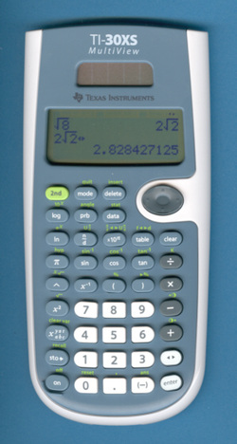

Materials

- Binder or Spiral notebook
- Pencil with eraser
- Calculator (suggested TI-30XS)
- textbook

Extra Help/Tutorial

Extra help will be available most days both before and after school. The easiest way to get help – ASK!!
Students that do not demonstrate proficiency may be required to work outside of classroom time.

Website

Please visit the website for information about the class and links to useful resources.

Classroom

No food or drinks may be consumed in the classroom, except water. Please clean up your workspace before you leave each day (including the floor). There should be absolutely no writing on desks, walls, or other parts of the classroom. Remain in your seat until the bell rings.

